Surgery on Sunday Louisville

Use Case Specification: Filling Out An Online Volunteer Form

Version 3.0

Revision History

|  |  |  |  |
| --- | --- | --- | --- |
| **Date** | **Version** | **Description** | **Author** |
| 10/21/17 | 1.0 | Filling Out An Online Volunteer Form | Cody Higdon |
| 11/6/17 | 2.0 | Filling Out An Online Volunteer Form w/ Prototypes | Cody Higdon |
| 12/7/17 | 3.0 | Filling Out An Online Volunteer Form w/ Prototypes | Cody Higdon |
|  |  |  |  |

Table of Contents

1. Use-Case Name 4

1.1 Brief Description 4

2. Flow of Events 4

2.1 Basic Flow 4

2.2 Alternative Flows 4

3. Special Requirements 4

3.1 First Special Requirement 4

4. Pre-conditions 4

4.1 Pre-condition One 4

5. Post-conditions 4

5.1 Post-condition One 4

6. Extension Points 4

6.1 Name of Extension Point 4

7. Class Diagram 5

8. Sequence Diagram 6

9. Use Case Diagram 7

10. Prototype 8

10.1 Prototype Description 8

10.2 Actual Prototype 8

Use Case Specification: Filling Out An Online Volunteer Form

# Filling Out An Online Volunteer Form

## Brief Description

The purpose of this use case is to describe how a volunteer will fill Out an Online Volunteer Form. This is necessary if a volunteer wants to volunteer their time to SOSL. This will help volunteers know what information SOSL is looking for in a volunteer for an event or fundraising event.

# Flow of Events

## Basic Flow

* A volunteer fills out the simple form

## Alternative Flows

### There are no alternative flows for this use case.

# Special Requirements

## The Database Administrator has to create the simple form for the volunteer to fill out.

# Pre-conditions

## The database administrator must have access to the organization’s system in order to create the volunteer to be able to fill out the form.

## Database administrator logs into the system.

## Database administrator creates a simple volunteer form.

## Database administrator saves the change.

# Post-conditions

## The volunteer will have to submit the form. This will alert the SOSL system.

## Database administrator logs off from the system.

# Extension Points

## There are no extension points for this use case.

# Class Diagram

**Volunteer**

**Attributes:**

* **Volunteer Form**

**Methods:**

**+ Fill Out ()**

# Sequence Diagram

Volunteer

**Object:** Volunteer Database

**Class:** Volunteer



Fills Out



# Use Case Diagram

The following diagrams show how the system will use the online volunteer form for volunteer to register. The volunteer steps through how the system can be used to add, edit, or delete that nurse from the database. For this assignment I have the filling out of the Volunteer form.



**UCID 040: Fill out online Volunteer form**

**UCID 041: Submit form to Volunteer Database**



Volunteer

**UCID 039: Delete Nurse Volunteer from Database**

**UCID 079: Login to system**

**UCID 012: Alert for Clinical Volunteer Database**

**UCID 037: Add Nurse Volunteer to Database**

**UCID 038: Edit Nurse Volunteer in Database**



Admin

SOSL Employee

**UCID 042: Check Alert**

# Prototype:

# 10.1 Prototype Description: This prototype is designed to show how the volunteers will fill out form. This form will be filled out by a volunteer to give their information to SOSL.

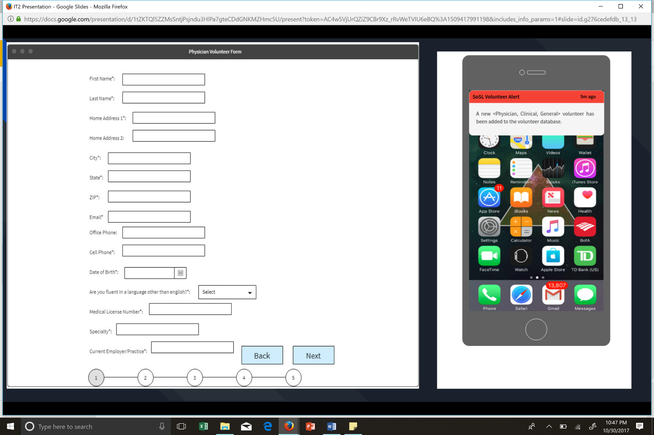 **10.2 Actual Prototype:**